

|  |
| --- |
| Investigating Vulnerabilities In IoT devices in the context of a smart home  Michael W Crow  BSc Ethical Hacking and Countermeasures, 2017 |

|  |
| --- |
| School of Arts, Media and Computer Games  Abertay University |

# Abstract

Jfjfgjgjg gobbledegook

Table of Contents

Abstract i

Table of Figures iii

Table of Tables iv

Acknowledgements v

Abbreviations, Symbols, Notation and Glossary of Terms vi

1. Introduction 1

1.1. Introduction to IoT 1

1.2. The Modern Smart Home 2

1.3. Business Implications 2

1.4. Future Projections 2

1.5. Penetration Testing and IoT 2

1.6. Devices Tested in this project 2

1.7. Research Aims 2

1.8. Research Objectives 2

1.9. Statement of Structure 2

Appendices 3

List of References 4

Bibliography 5

# Table of Figures

# Table of Tables

# Acknowledgements

# Abbreviations, Symbols, Notation and Glossary of Terms

If required

## Introduction

In the modern age in which we live very few aspects of life are hidden from the ever advancing wave of modern technology, According to the office for national statistics in 2016, 89% of households in the UK had access to the internet [1] this compared to just ten years before in 2006 when only 57% of UK households had access to the internet highlights the extraordinary popularisation and advancement of the industry in the last decade alone.

With the benefits of technology now firmly cemented into the daily routine of the everyday person, developers of the industry are constantly producing new and intriguing ways in which technology can benefit people in making their lives easier and more productive.

At the forefront of this exciting time in technological advancement lies the subject of the Internet of Things or IoT.

### Introduction to IoT

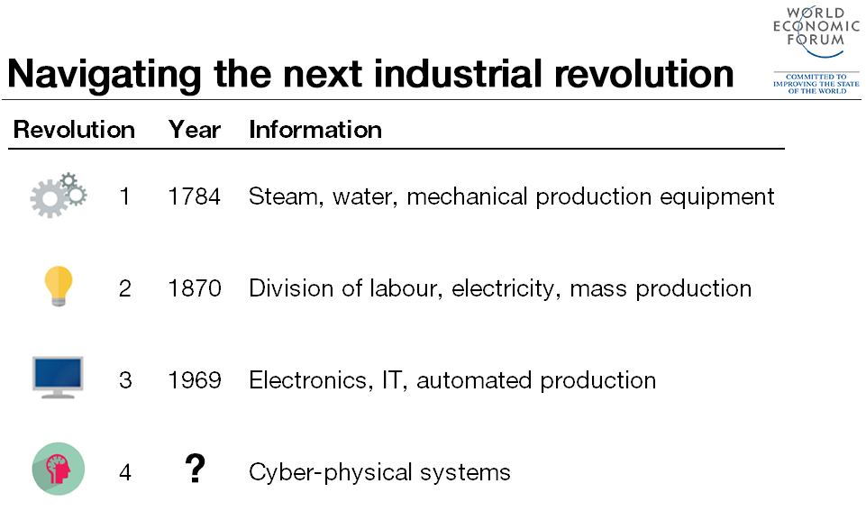Since its invention in the late 1960s as a part of the third industrial revolution, the internet as we know it has underwent many transformations most notably the invention of the World Wide Web by Sir Tim Berners-Lee in 1990 which introduces the world to the concepts and advantages of interconnectivity. The most modern development in the internet is represented by the concept of the Internet of Things (IoT) is considered by many industry and economic experts as the possible fourth industrial revolution combined with artificial intelligence[2].

Table 1 – Fourth Industrial Revolution – World Economic forum (Klaus, 2016) [2]

the internet was accessed daily by 82% of adults over the age of 16 in the UK [1], That Amounts to 41.8 Million individuals across the country, this statistic may seem unsurprising but in an ageing uk population it is rather impressive

### The Modern Smart Home

### Business Implications

### Future Projections

### Penetration Testing and IoT

### Devices Tested in this project

### Research Aims

### Research Objectives

### Statement of Structure

# Appendices

# List of References

[1] Office for National Statistics, “Internet access – households and individuals: 2016” (4/8/2016) [Online] Available at: <https://www.ons.gov.uk/peoplepopulationandcommunity/householdcharacteristics/homeinternetandsocialmediausage/bulletins/internetaccesshouseholdsandindividuals/2016> [Accessed March 2016].

[2] Klaus, Schwab, “The Fourth Industrial Revolution: what it means, how to respond” (14/1/2016) [Online] Available at: <https://www.weforum.org/agenda/2016/01/the-fourth-industrial-revolution-what-it-means-and-how-to-respond/> [Accessed October 2016].

[3] Oxford Dictionary, “Internet of Things” [Online] Available at:

<https://en.oxforddictionaries.com/definition/internet_of_things>

[Accessed September 2016].

# Bibliography

If required